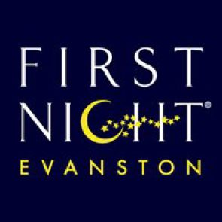

For Immediate Release: Contact: Emily Guthrie firstnightevanston@gmail.com
December 6, 2021
First Night Evanston is “Closer Than in Person” with a virtual 25th New Year’s Eve Variety Show
We invite you to join us from the comfort of home for a special New Year’s virtual music event on Dec. 31 featuring blues and harmonica legend Corky Siegel and Friends. This “closer than in person” event will be presented online starting at 9:45 p.m. with a special live Q and A with the musicians after the show.
“My wife Holly and I are thrilled to serve as master of ceremonies for this incredible music spectacular filled with surprises from our esteemed and diverse featured artists,” Siegel said. “This year's virtual New Year's Eve concert is shaping up to be the best yet, so please help us support the arts and First Night with a contribution of any amount."
This all-ages extravaganza includes offers something for everyone with performances by outstanding artists from Chicagoland and beyond, featuring:
Alvy Ray Smith, Billy Branch, Blair Thomas with Michael Smith, Chamber Blues, Corky Siegel, Dorothy Scott, Howard Levy, Last Word Quintet, Phil Bimstein, Sones of México, Sons of the Never Wrong, Toronzo Cannon, Lynne Jordan, Ernie Watts, Wayne Baker Brooks and Will Tilson.
A recommended $35 (or more!) contribution reserves your “seat” for more than two hours of music, poetry, puppetry and interviews, immediately followed by a live countdown to midnight and singing of Auld Lang Syne in a special “Ring in the New Year” Zoom with everyone invited. This virtual concert is free and open to the public.
"This year marks the 25th anniversary of First Night Evanston, and I am honored to be a part of this special celebration,” said Emily Guthrie, Vice President of First Night Evanston. “In the spirit of community and making the arts accessible to the community-at-large, we have brought together a diverse lineup of musicians and artists to ring in 2022 together. Most importantly, thanks to our sponsors and community members who contribute what they can, we are able to make this virtual concert free and open to all.”
Your generous contribution helps fund this blockbuster lineup of iconic performers, supports the artists’ work and ensures that this special 25th anniversary of First Night is the biggest one yet. More importantly, your contribution helps make this event accessible to all members of our community.
Special thanks to this year’s First Night Evanston sponsors Byline Bank, Northwestern University, Romano Wealth Management, Kiwanis Club of Evanston and Hecky’s Barbecue for their valued support of this special event.
To make a contribution and register for the First Night Evanston 25th New Year’s Eve Variety Show, please visit: https://tinyurl.com/ycku5uts

---xxx---

