On-Line WNUR Log Sheet

- Go to https://forms.office.com/r/zhWBJNYTQW which is also bookmarked on the music Computer in Chrome

Or Scan this QR code on your Mobile Device

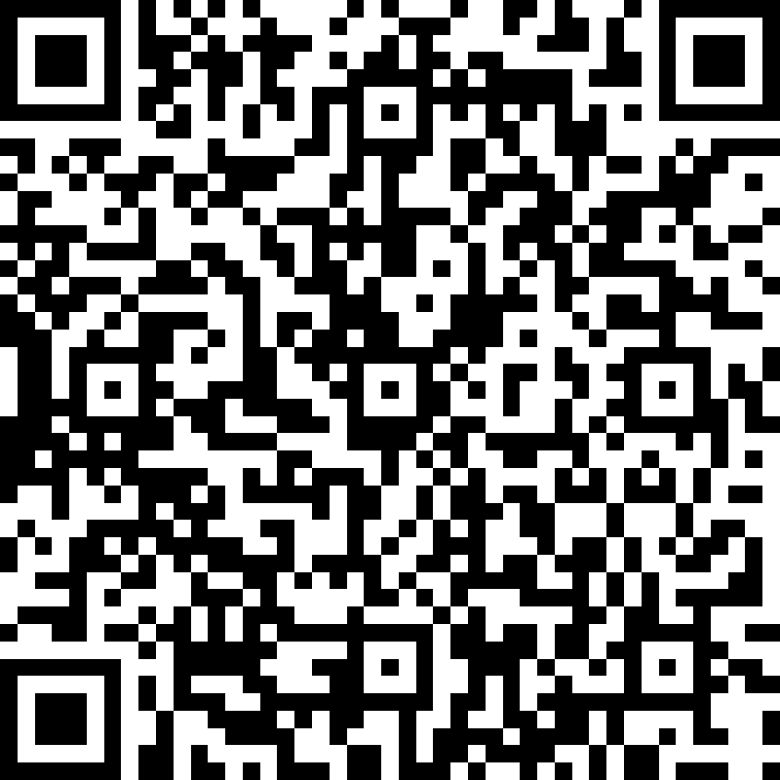

- Complete all the questions on the form, some of which will need to be completed at the end of your show.
- Summit the form.

