Wheatstone Preset Instructions:

First press the arm button as seen below:

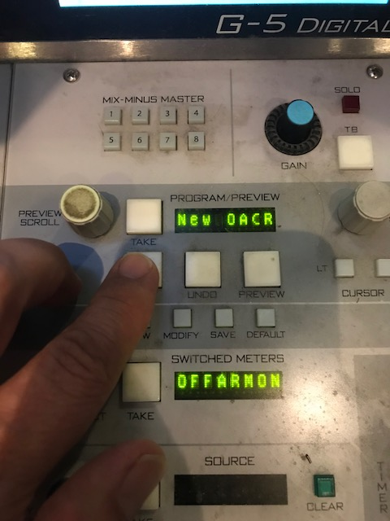

The buttons will light up

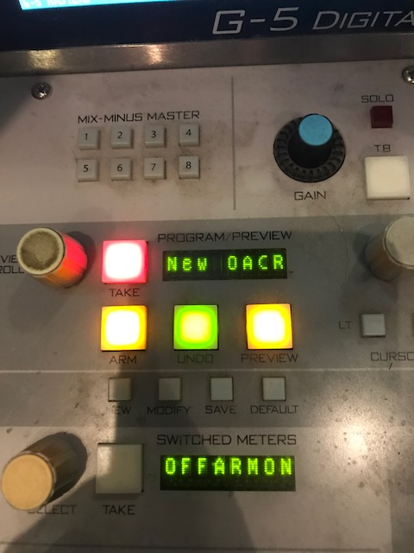

Then use the preview scroll knob to select the desired preset. We recommend using New OACR. It was setup and tested by Wheatstone.

Once you have New OACR in the Scroll, press the take button

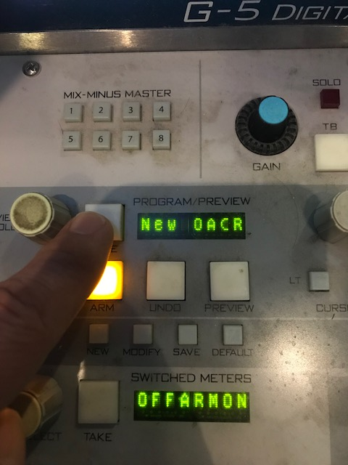

It should then read New OACR and it will change the inputs on the console.

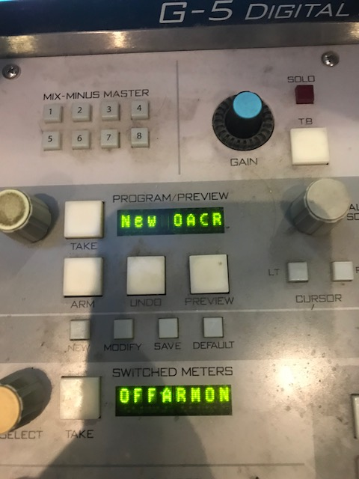

This is the best way to change the preset. We are aware some people use the SoloDJ preset. If this works for you, great, but we strongly recommend using New OACR.